Electrothon

Greetings of the day,

Done with all-night cramming sessions, over-caffeinated group studies and staying up for days to prepare for the exams? Now it’s time to think out-of-the box, fuel your ideas, discover technology and create something groundbreaking.

Team SPEC declares ELECTROTHON 2020 open!

Electrothon mainly has two tracks, hardware track and software track. The subdomains covered in the contest are:

1. Internet of Things

2. Mixed Reality / Augmented Reality / Virtual Reality

3. Machine Learning / Artificial Intelligence

4. Embedded Systems

5. Web / App Development

6. Miscellaneous

You have to propose innovative ideas aimed to reduce human efforts, enhance user experience, and solve generic social problems using emerging technologies. As of now, you just have to register yourselves with us on Devfolio portal.

So come, accelerate your education, get in front of the top companies in the world, meet peers who are also building things, and best of all, grab some awesome T-Shirts and goodies and cash rewards from our sponsors.

So, dive right in, and follow these steps to register for the contest:

1.Visit our website (<http://specnith.com/hackathon.html>)

2.Click on Apply with Devfolio button.

3.Complete your profile (Resume upload is optional)

4.Submit Profile for Review

You can register individually or in teams of 2-4.

And you’re done, see you in January with a bunch of cool ideas.

Registrations will start from 5:00 pm, December 7, 2019(Today)

Last Date to register is December 31, 2019.

Workshop by mycaptain

FIRST STEP TOWARDS YOUR PASSION.

Workshops enlisted above is being organized by MYCAPTAIN, a company incubated from IIM Bangalore.

When you enroll yourself for any of the workshops you get :

* Personal Mentor and lifetime access.

* Live classes with the flexibility of choosing your own month.

* Certificate recognized by IIM Bangalore and United Nations.

* LOR ( Letter of Recommendation ) recognized by IIM Bangalore and United Nations.

* Paid Internships ( work from home/ work from office ) on your field of interest.

Interested applicants may text me at 9431829826, somya sinha, for any query or procedure.

This Winter, beat the cold by rekindling your Passion!

Are you interested in building your own startup? Or maybe becoming a Finance guru? Or even a Digital Marketer in the future? MyCaptain is here with it’s special series of Workshops in the hottest business fields.

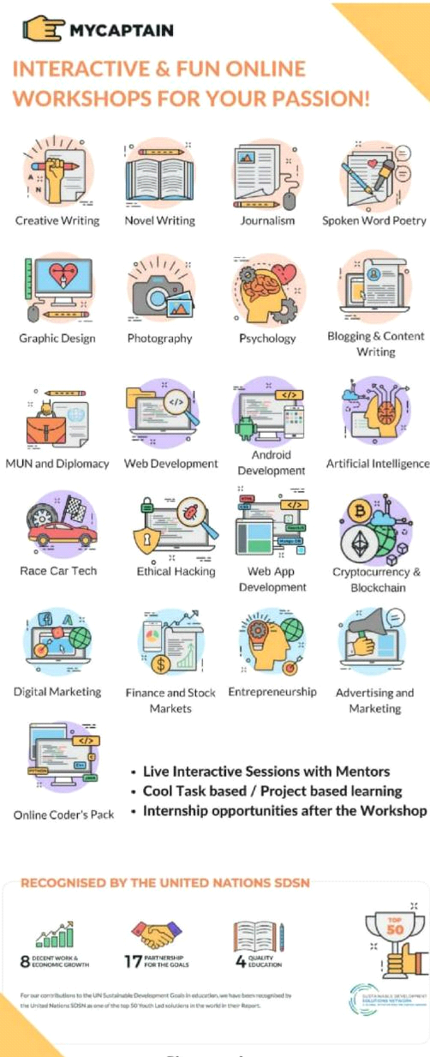

Apply now:

You could get mentored Live in our Online Classes in:

- Entrepreneurship

- Marketing & Advertising

- Digital Marketing

- Finance & Stock Markets

All of this and more, just at Rs. 3500/- , carefully curated just for you.

Why you can’t miss this chance?

- 8-10 hours of Live Online video Classes

- Lifetime access to all the Content

- Build Projects with your Mentor

- Certificates and LoRs from MyCaptain

- Join India’s most Passionate learning Community

How it works?

<https://youtu.be/hTUN9muiDVk>

*Apply now:*http://bit.ly/MyCaptain_Workshop_Mentoring1

Geeks coding challenge

[10:53, 12/12/2019] Aryan Mechanical: GeeksforGeeks is organizing Geeks Coding Challenge (GCC) - a three-day coding event commencing from 27 Dec 2019. It is a free event to allow all the coding techies out there to showcase their skills and win prizes worth more than 6 lakhs including several cash prizes.

The challenge is divided into 3 rounds with an increasing difficulty level. 250 coders will be shortlisted from Round 1 for the Round 2. Similarly, 100 coders will be shortlisted for the final round.

For complete details visit: <https://practice.geeksforgeeks.org/contest/gcc-day-1>

Round 1: 27 Dec 2019 | 8:00 PM IST to 9:30 PM IST

Round 2: 28 Dec 2019 | 8:00 PM IST to 10:00 PM IST

Round 3: 29 Dec 2019 | 8:00 PM IST to 10:00 PM IST

Prizes: Cash prizes + Live session with Mr Sandeep Jain (Founder & CEO, GeeksforGeeks) + Free Courses ( Placement 100/DSA Self Paced course) + GfG discount coupons and much more.

Subjects tested is the contest: Data Structures & Algorithms

Excited to prove your metal among 20,000+ coders from all over the world?

Hurry! Participate Now. Limited Seats Only!

Visit: <https://practice.geeksforgeeks.org/contest/gcc-day-1>

[10:53, 12/12/2019] Aryan Mechanical: Get started with coding and win prizes worth more than 6 lakh and free courses

[10:53, 12/12/2019] Aryan Mechanical: Use this registration code GFGIO32B4

[16:24, 12/12/2019] Aryan Mechanical: Hey students!

Here is an Exciting Winter Online course opportunity from Mycaptain!

My captain an organisation from IIM Bangalore has come to provide workshop for you all. You can get certificates recognized by United Nations and IIM Bangalore!!! With an internship opportunity

The Online workshops are now available with Special power packs with Exciting offers

And yeah its only for limited time😊!

So go register for your favourite course in the below link🤖 and soon a Mycaptain representative will contact you to guide you for the glory😇!

All the best! 🥳

Click here to Register: <http://bit.ly/2PodrcL>

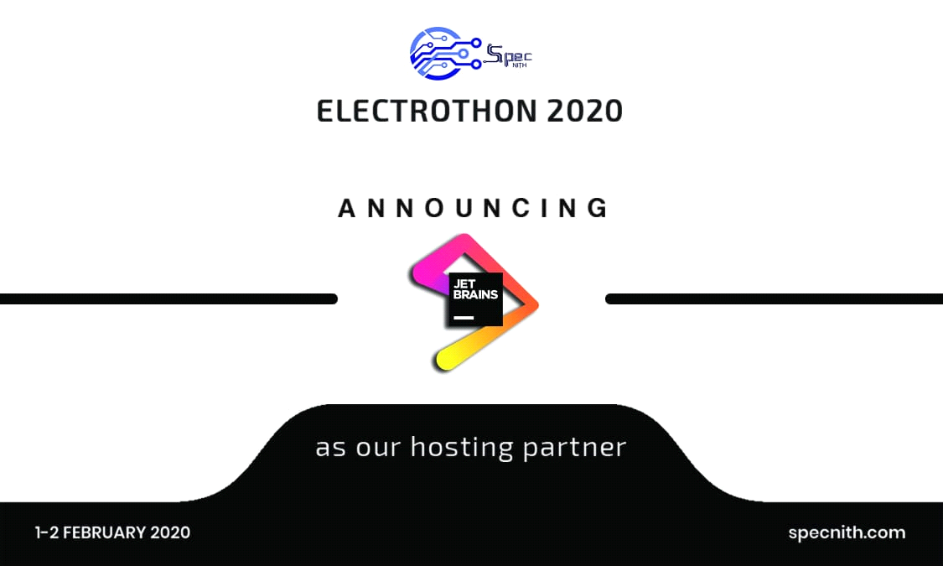

**PRODYOGIKI**

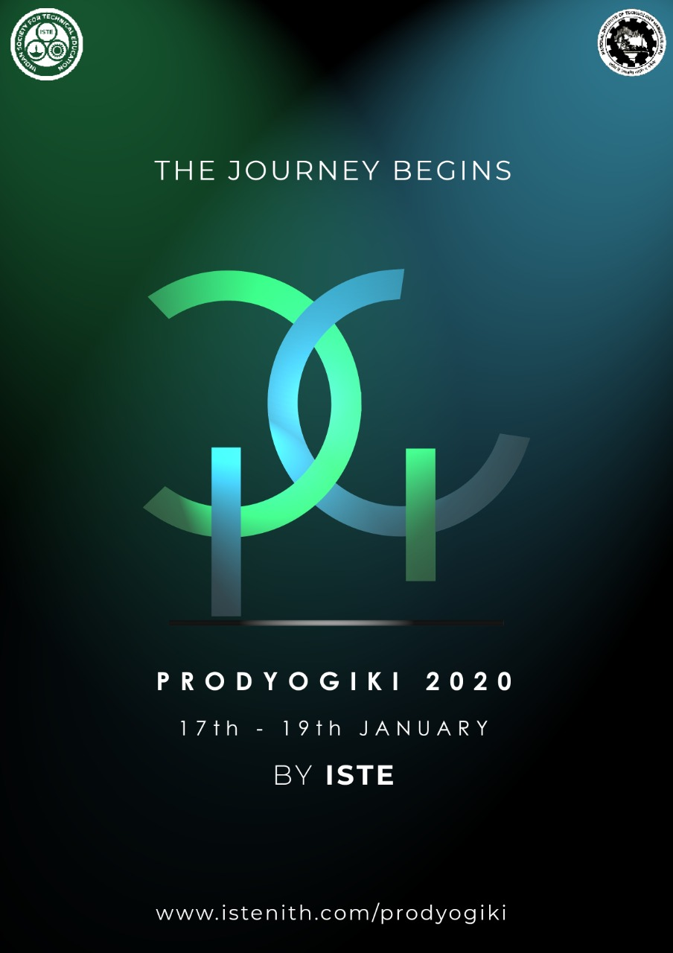

Greetings NITians!

Technology is not merely a gimmick to inspire education, but its beauty is truly understood if we remain up-to-date with the latest developments around us.

It is with great pleasure that we declare the onset of the Annual Technical Festival of ISTE Students' Chapter NIT Hamirpur- PRODYOGIKI 2020 !!

Prodyogiki involves a chain of seminars, workshops, interactive events, quizzes and various other student activities. So all technocrats out there, get ready to be challenged and motivated as we wish to tickle your technology buds!

Prodyogiki, mark the dates 17-19 January , will give you the opportunity to observe the zenith of innovation & pursue your technological interests with different mind-boggling and fascinating activities.

So, Get-Set-Go! Let the journey begin!

Further unveiling of the events will take place soon and for the detailed information do go through our website.

Website Link:

[www.istenith.com/prodyogiki](http://www.istenith.com/prodyogiki)

**LOST LANDER**

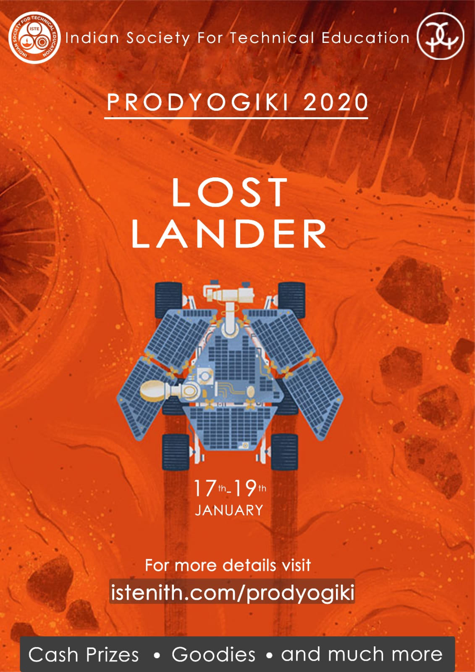

In a far far away galaxy, one of those that we do not see through our naked eyes, there lived these three friends. Belonging to an extraterrestrial alien species entirely different from us humans, they were thriving and advancing in technology. Traversing throughout the space was a normal thing for them. Once they decided to explore the nothingness of the space, and built a spacecraft that could go and collect data from a specific target planet from which they had previously received communication signals.

Once they paved a pathway for their spacecraft to enter the planet’s orbit, they were successful in establishing their rover on the surface. All information was being transferred well until one day the rover’s camera was damaged and they were having tough time making a connection with it....

Team ISTE is back again with yet another version of its exhilarating technical festival Prodyogiki 2020. So here we present our first event, Lost Lander.

The challenge is to make a bot that you would control and navigate across an arena filled with obstacles.. Easy right?

Well did we just forget to mention that your bot can not have any camera on it.

And also the fact that you wont be able to see the arena while your bot tries to navigate through it.

The bot that croses the arena in the least time will be declared the winner!

So gear up and get a chance to win some exciting prizes..

For more information, visit:

istenith.com/prodyogiki

**crazy crawler**

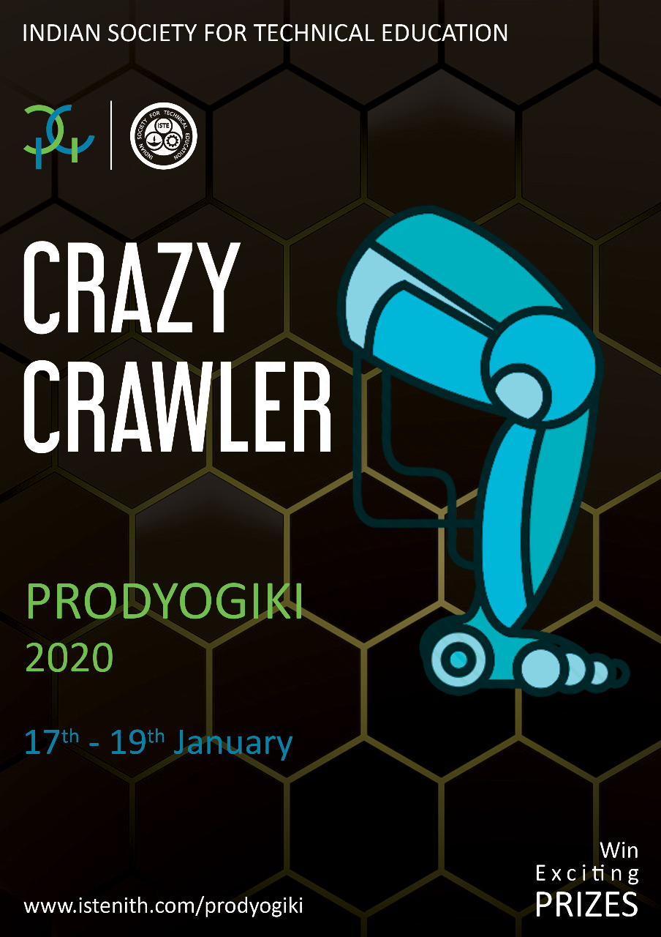

Greetings NITians!!

Now that our alien friends have successfully established a connection with their lost lander and designed a grandiose house to reside on the planet yet they are finding it difficult to travel on this foreign terrain and something that captivated them the most was a creature with legs, balancing on its own which could easily move on this surface. Inspired by this concept, they decided to build a similar sort of vehicle for themselves too.

Can you help them out?

Revealing another thrilling event of Prodyogiki 2020 by team ISTE the CRAZY CRAWLER challenge.

The challenge is to make a self-driven legged bot which is made up of different mechanically operated parts that collaborate in moving effectively without using wheels. Bot should be capable of moving in straight line.

The bot that dashes through a straight course in minimum time will be declared the winner!

So gear up and stand a chance to win some exciting prizes...

For more information, visit:

istenith.com/prody

E SUMMIT REGISTRATION

Hello

Greetings from EDC NIT Durgapur

It's my pleasure to inform you that Esummit' 2020 is just around the corner and will soon be knocking on your doors on 14, 15, 16 Feb'20 It's one of its kind and the 2nd largest Entrepreneurial meet in East India.

The past editions of Esummit have hosted speakers from numerous backgrounds like

Prajakta Koli (popularly known as MostlySane, YouTube personality); Pauline Laravoire (Founder of Y-East, Sustainability Director of Techno India, Co-Founder of AQWA); Rahul Kaushik (Founder of 'The Melting Words'); Ravi Ranjan (Entrepreneurship Evangelist, Start-up Expert, TEDx Speaker) and many more.

We conduct lots of fun events such as Boardroom, Auction Arcadia and workshops on Stock Market, Digital marketing etc. by top professionals. We are also providing an opportunity to pitch your startup ideas in front of reputed investors.

So what are you waiting for? Register at <https://docs.google.com/forms/d/1sqZ7J5BfpDM-7ybJNCuMAQFywGowt0S14M5O0dlCb3s/edit> to participate. We will soon give you details of all events and competitions. Looking forward to having you along with your friends in NIT Durgapur.

Ankit Rai

Public Relations Coordinator

EDC NIT Durgapur

For any queries, DM at 9432369032 via Whatsapp

Follow us at

Facebook- <https://m.facebook.com/edc.nitd/?ref=bookmarks>

Instagram- <https://www.instagram.com/edc.nitd/>

Have a look at our Esummit'19 Aftermovie at <https://youtu.be/ciM_7zO2Kc8>

**CODING BLOCK**

We are thrilled to introduce Coding Blocks as our Sponsor cum Workshop partner.

Coding blocks is India's one of the best programming and software training institute that offers various courses. Coding blocks is the podcast for learning how to become a better software developer. Code your way to success and coding blocks will prove to be the best guide.

Coding Blocks will be giving discount coupons, T-shirts, and stickers to the winners.

Check them out on👉🏻 [https://codingblocks.com](https://codingblocks.com/)

**TECHGIUM**

<https://ind01.safelinks.protection.outlook.com/?url=https%3A%2F%2Flntts.techgium.com%2F&data=02%7C01%7Carchana.S%40Ltts.com%7Cda2118eea4ed499ba89a08d778a1a1de%7C311b33788e8a4b5ea33fe80a3d8ba60a%7C0%7C0%7C637110507900836513&sdata=hOwgvZS2BMAP3Vj%2Fzt3gYLvhF1qyMMzpzPwCUnU5f%2FU%3D&reserved=0>

**CPBA**

Chirag Daga(CPBA)- Want to have similar Hallmark of CBAP next to your name??

Do you want to become a Data-Driven Decision Making Professional ??

If the answer is "Yes" to any, then the Certified Python Business Analyst Program by Henry Harvin Education is a perfect option to go with.

This is a 4-days/32-hours Training and Certification Program that equips professionals to Explore+Analyze+Solve Business Problems using Python. This enables students to understand analytics-based decision making to drive company's ROI

It is very popular in IIM's for its learning while doing teaching style. It surely helps in improving your CV, adding new skillset. Thus, better placements.

Fees: INR 5000/-

**FROST HACK**

Hello people!

IIT Mandi is calling out all the cyber geeks out there to grab their PCs and dive into their computer screens because registrations for FrostHack are now open!

So put on your hoodies and set up your screens to experience an enigma of ideas and innovations here in the Himalayas.

To start the process, simply head to our website <https://frosthack.com/> and click on the "Apply with Devfolio" button.

In case of any question or queries, visit the "Contact us" section in the website.

For timely updates follow us on instagram: <https://www.instagram.com/frosthack_iitmandi/>

and join us on facebook : <https://www.facebook.com/frosthackiitmandi/>

#hackathon #frosthack #backtohills #iitmandi

Interested? Fill the Google Form: <http://bit.ly/2EWOFMd>

Regards,

Mayank Dhiman

95213 98978

NIT Hamirpur

**MOBILE PHOTOGRAPHY EVENT**

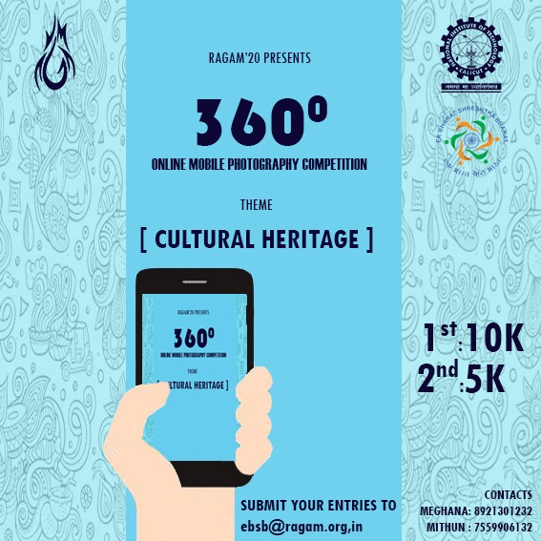

Every picture speaks a thousand words, and our Mobile Photography event 360° is your chance to share your story with the world. Let your lens do the talking and showcase the stunning realities you capture on the Cultural Heritage of your motherland Himachal Pradesh. Send in your best clicks and get featured this Ragam’20 in collaboration with the Ek Bharat Shrestha Bharat campaign. Moreover exciting prizes await the best entries. Send your submissions to ebsb@ragam.org.in .

**DATA SCIENCE AND IOT WORKSHOP**

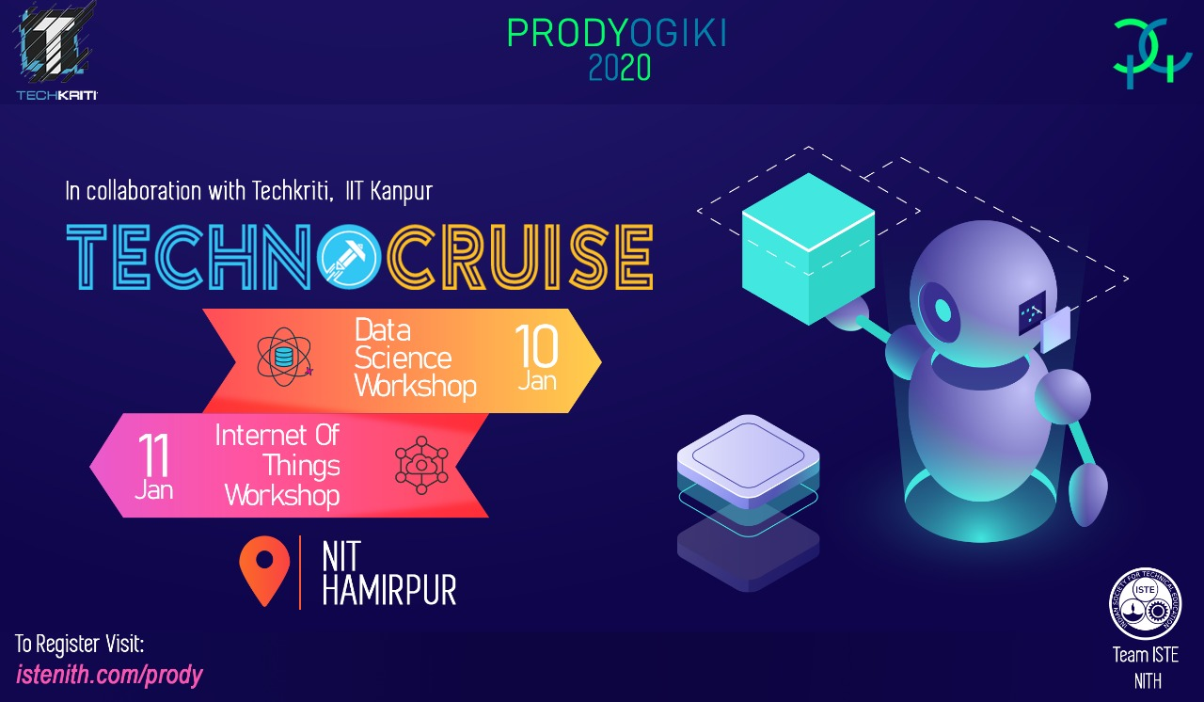

Greetings NITians

Data Science and IoT are one the most popular field among engineers. So why not show the world what you are capable of. But wait? For the world to recognise you you should have skills. So to help you gain some amazing skills ISTE (NIT Hamirpur) brings you an amazing workshop in collaboration with Techkriti (IIT Kanpur) on DATA SCIENCE and IoT

Benefits to the participants:

1) We will be providing certificate of participation to each students in which there would be a sign of our Dean of student's affairs; Festival Chairman & Coordinator.

2) The certificate maybe used further in their CVs

3) You'll get some discount on ML course and a certificate signed by the CEO of Microsoft Satya Nadella, This will be done through Foxmula, a Microsoft Associate.

4) There will be test conducted by technocruise on "Data Science", qualifying this test will provide free entry at the techfest of IIT Kanpur's workshop and participants need not to pay any fee for the test.

5) Workshops are intoductory so you need not to have any prior knowledge about this.

Register Fast !! Limited Seats available!!

[www.istenith.com/prody](http://www.istenith.com/prody)

**ADVITIYA**

Hi guys, greetings from Advitiya IIT Ropar and CIM(Computer Integrated Manufacturing) Club IIT Ropar. This year Advitiya is being organised from 7th to 9th February 2020. Please see all events in Advitiya @ <https://www.advitiya.in/events/>. We are organising 3 CAD events this year of which 1 event is online as well. Please see our CAD events and the rulebooks @ <https://www.advitiya.in/events/#CAD>. Please register ASAP by paying a nominal one time fee of INR400 to participate in any number of events in Advitiya IIT Ropar. Please note that although the fest is scheduled to be held on 7-8-9 February 2020, problem statement for online event will be released 15 days before the fest.

For more information, feel free to contact:

1.Ayush Agarwal- Contact no. 9927873406

2.Abhishek Ashish- Contact no. 8292582019

**INT ACT**

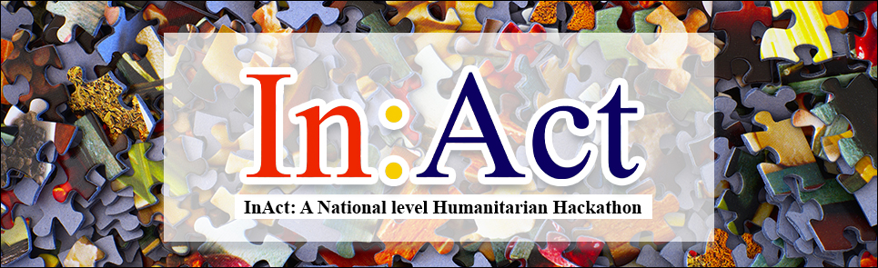

Hi Everyone,

Symbiosis Statistical Institute is organizing a National level Humanitarian Hackathon. Distinct from the usual ones:

• Virtually preparing a month back

• 48 hours final problem solving session

• Interdisciplinary teams, people from all domains

• Brilliant mentors from the likes of UN, CERN, gluoNNet and others

Register now: <https://inact.ssi.edu.in/>

**ROBOTICS workshop**

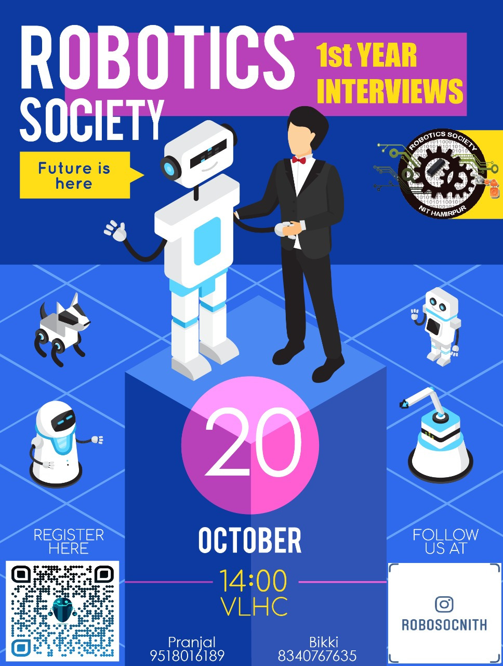

Greetings First Year

We were glad to see you all perform so well with so much zeal and enthusiasm in the AI Bot Workshop.

Now do you want to climb the higher steps of the stair and carry forward your zest in the domain of Robotics and get hands-on-experience in the blossoming field of Artificial Intelligence, Computer Vision, IOT and much more?

If your answer is yes, then gear up for the interviews. Extemporize and evince your skillset to become a part of Robotics Society,NIT Hamirpur.

Even if you missed out the chance to attend the workshop and begin your expertise in this field, walk-in for the interviews as opportunity seldom knocks twice.

Seize this opportunity and register for the interviews at:

<https://forms.gle/aQ2nb8kPS6xbD2mS8>

Venue-LH.

Date-20 October 2019

Time- 2:00 p.m.

Contact-

Pranjal- 9518016189

Bikki - 8340767635

Facebook-

fb.com/robo.soc.nith

**SPEC WORKSHOP**

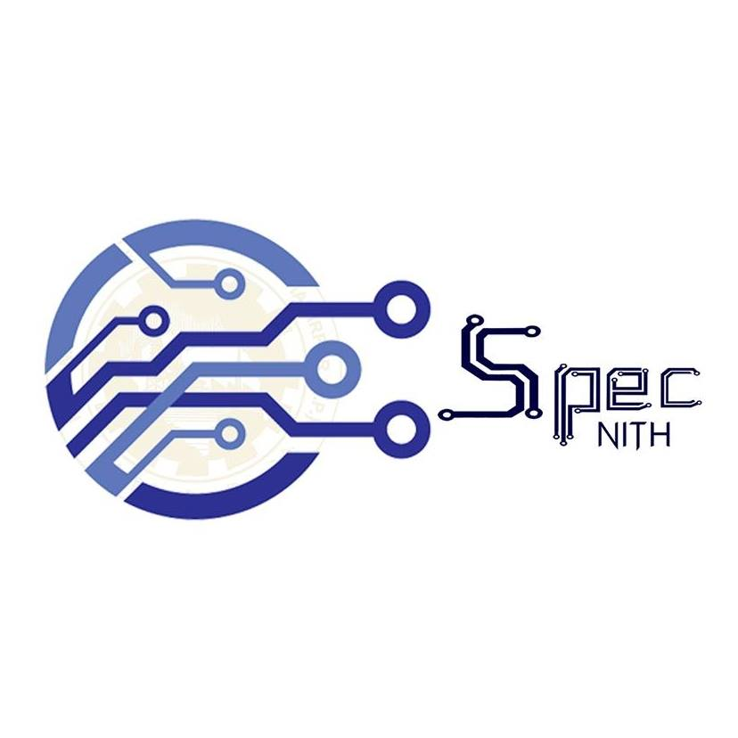

SPEC betoken as Society for Promotion of Electronics Culture is a community that conducts various activities, workshops and competitions to improve students’ technical culture.

The team works on annual projects based on emerging state-of-the-art technology and invites the enthusiast to join hands with us as well as inviting renowned guest speakers from across India to share their life experience and prestigious words during our various technical events coupled with the fun bonanza and other competitions conducted at regular period which is a major hit among the students. One of the major event organize is the Electrothon where different teams come up with their innovative ideas and projects about the world's modern technology trends. We come daily on the latest technology with new forums, posts, interns, and domains. For regular updates and to know more about the new technological ideas follow our Social Media accounts. We'll keep you updated.

Keep Learning!!✨

Facebook: <https://www.facebook.com/spec.ece/?ref=bookmarks>

Instagram: <https://www.instagram.com/s.p.e.c_nith/?hl=fi>

LinkedIn : <https://www.linkedin.com/in/s-p-e-c-nith-40214b197/>

Twitter: <https://twitter.com/SPEC91853213?s=08>

Official Website:

<http://nith.ac.in/spec/>